



Development Standards & Practices Used

Midi-USB Protocol

AES3 Digital Audio Protocol

IEC 60958/AES14 Analog Audio Protocol (¼ inch & XLR analog input/output)

IEEE 315 Specifications for Electrical Design Documentation

IPC-2221 General Specifications for PCB design

IPC-2222 Specifications for PCB design related to high-frequency signal processing

Summary of Requirements

1. Audio Quality & Accuracy
   1. The Final Product should be an accurate emulation of audio passed through a Vacuum-Tube Pre-Amplifier
   2. Final Product should have an easily discernible audio without unwanted distortion or volume/peaking issues
2. Size & Reliability
   1. Final product should be small enough to be moved easily by a single person with little effort, and stored with other instruments
   2. Should remain functional even when exposed to temperature shifts, impacts, minor moisture exposure, etc.
3. Cost
   1. Final product should be significantly cheaper than a similar quality Vacuum Tube/ Vacuum Tube Emulator alternative

Applicable Courses from Iowa State University Curriculum

List all Iowa State University courses whose contents were applicable to your project.

* EE 230
* EE 330
* EE 224
* EE 324
* CprE 281
* Com S 309
* CprE 288
* Music 224

New Skills/Knowledge acquired that was not taught in courses

Gitlab management

Audio processing

Mathematical Extrapolation

Table of Contents

1 Team, Problem Statement, Requirements, and Engineering Standards 5

1.1 Team Members 5

1.2 Required Skill Sets for Your Project 5

(if feasible – tie them to the requirements) 5

1.3 Skill Sets covered by the Team 5

(for each skill, state which team member(s) cover it) 5

1.4 Project Management Style Adopted by the team 5

1.5 Initial Project Management Roles 5

1.6 Problem Statement 5

1.7 Requirements & Constraints 5

1.8 Engineering Standards 5

1.9 Intended Users and Uses 6

2 Project Plan 6

2.1 Task Decomposition 6

2.2 Project Management/Tracking Procedures 6

2.3 Project Proposed Milestones, Metrics, and Evaluation Criteria 6

2.4 Project Timeline/Schedule 7

2.5 Risks And Risk Management/Mitigation 7

2.6 Personnel Effort Requirements 7

2.7 Other Resource Requirements 7

4 Design 8

4.1 Design Content 8

4.2 Design Complexity 8

4.3 Modern Engineering Tools 8

4.4 Design Context 8

4.5 Prior Work/Solutions 9

4.6 Design Decisions 9

4.7 Proposed Design 9

4.7.1 Design 0 (Initial Design) 10

Design Visual and Description 10

Functionality 10

4.7.2 Design 1 (Design Iteration) 10

Design Visual and Description 10

4.8 Technology Considerations 10

4.9 Design Analysis 10

5 Testing 11

5.1 Unit Testing 11

5.2 Interface Testing 11

5.3 Integration Testing 11

5.4 System Testing 11

5.5 Regression Testing 11

5.6 Acceptance Testing 11

5.7 Security Testing (if applicable) 11

5.8 Results 11

6 Implementation 12

7 Professionalism 12

7.1 Areas of Responsibility 12

7.2 Project Specific Professional Responsibility Areas 12

7.3 Most Applicable Professional Responsibility Area 12

8 Closing Material 12

8.1 Discussion 12

8.2 Conclusion 13

8.3 References 13

8.4 Appendices 13

8.4.1 Team Contract 13

List of figures/tables/symbols/definitions (This should be the similar to the project plan)

# Team, Problem Statement, Requirements, and Engineering Standards

* 1. Team Members

1) Benjamin Mullin 2) Theodore Burnick

3) Julia Kroeper 4) Ian Bixler

5) Bradley McClellan 6) Jack Cassidy

* 1. Required Skill Sets for Your Project

Electrical Engineering:

* Circuit design
* Hardware implementation
* Testing and certification
* Analog Audio Processing

Computer Engineering:

* Microcontroller component sourcing
* Microcontroller implementation
* Programming
* Interface testing
* Git Control Flow

Software Engineering:

* Programming
* Debugging and Troubleshooting
* Git Control Flow

Music Technology

* Digital Audio Processing
* MIDI Programming

* 1. Skill Sets covered by the Team

Electrical Engineering:

* Theodore Burnick
* Julia Kroeper
* Ian Bixler

Computer Engineering:

* Jack Cassidy
* Ben Mullin

Software Engineering

* Bradley McClellan
* Jack Cassidy
* Ben Mullin

Music Technology

* Theodore Burnick
* Ben Mullin

* 1. Project Management Style Adopted by the team

### Kanban-style management.

* 1. Initial Project Management Roles

Theodore Burnick: Team Lead

Julia Kroeper: Client Interaction

Ben Mullin: Programmer

Jack Cassidy: Secretary

Ian Bixler: Audio Distortion Effect

Bradley McClellan: Programmer

## Problem Statement

We are trying to replicate and provide the means to manipulate the distortion created by a vacuum tube amplifier. Musicians often use ‘sound effect’ devices to manipulate the sound that comes out of an instrument. Vacuum tube amplifiers are said to produce a unique type of distortion which many people have grown to appreciate. Our project will attempt to provide a solid state design to replicate this type of distortion at a lower price. We will also attempt to provide the means to manipulate the distortion so that musicians may use our device as more than a simple amplifier.

## Requirements & Constraints

For functional requirements, we are tasked with constructing a circuit that can replicate/improve upon the audio signal distortion introduced by a vacuum tube using solid state components to reduce cost and increase reliability. This distortion replication can be achieved either through digital signal processing, through a microprocessor contained within the device, or through purely analog solid-state Integrated Circuit components. The device should also have interfaces with most types of instruments in order to maximize the potential user base. This will include standard analog audio formats (i.e. XLR, 3.5 mm, ¼ inch) as well as ports for MIDI interfacing. The device should also have an easily comprehensible user interface attached to the device in order to minimize the difficulty of changing settings on the fly, while also having a more in-depth interface when attached to a computer for building custom settings.

## Engineering Standards

Midi-USB Protocol

AES3 Digital Audio Protocol

IEC 60958/AES14 Analog Audio Protocol (¼ inch & XLR analog input/output)

IEEE 315 Specifications for Electrical Design Documentation

IPC-2221 General Specifications for PCB design

IPC-2222 Specifications for PCB design related to high-frequency signal processing

## Intended Users and Uses

Our device primarily targets musicians seeking a versatile tool for sound manipulation across various genres and skill levels. It offers a user-friendly yet powerful platform to enhance auditory expression. Additionally, we cater to enthusiasts who appreciate the distinctive sound of vacuum tube amplifiers but may face budget constraints. Our device provides an affordable alternative, expanding our user base to include audiophiles and hobbyists seeking premium audio experiences without the hefty price tag. By serving these diverse audiences, we aim to democratize access to high-quality sound manipulation tools and the unique sonic qualities associated with vacuum tube amplifiers.

# Project Plan

## 2.1 Task Decomposition

1. Testing Tubes for distortion and performing spectral analysis
   1. Harmonic & Sinusoidal Distortion Analysis
   2. Clipping Characteristics
   3. Filament Temperature Analysis

The goal of this project is to learn to replicate the unique sound characteristics of a vacuum tube audio amplifier with solid-state components. To complete this task, we must first ascertain what distortions a vacuum tube amplifier introduces to an audio signal.

1. Work with a microcontroller to implement midi-usb and other components
   1. Analog/Digital Inputs & Outputs
   2. Audio Manipulation with Microcontroller Software

To manipulate an audio signal with as much precision and variability as possible, while also maintaining a small physical footprint, we must learn to use audio processing techniques on a microcontroller.

1. Derive a mathematical model of tube distortion
   1. Quantify the Distortion as found in task 1

To be able to process audio in the manner we wish to on the microcontroller, the complex electrical properties of the vacuum tube must be quantified and reduced to a mathematical model which can be used by the microcontroller.

1. Implementation of model using microcontroller.
   1. Create and Design circuit, buy necessary parts
   2. Program microcontroller (C++)

Once a Mathematical model has been found, we must implement such a model into a format that can be easily used by the microcontroller for audio processing.

1. Finalizing design document.
   1. Group editing sessions
   2. Client documentation approval

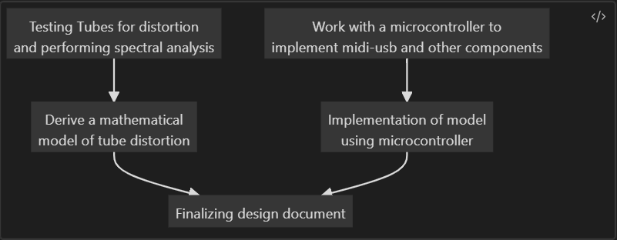

## 2.2 Project Management/Tracking Procedures

Our team will utilize GitHub for version control, milestone tracking, and issue management, streamlining collaboration and ensuring efficient code integration. Discord will serve as our central communication hub, facilitating real-time discussions, announcements, and meeting coordination. Additionally, we commit to providing weekly project progress reports to Professor Gieger every Friday. This structured reporting approach aims to keep our professor informed, seek valuable feedback, and maintain alignment with academic and project goals. Through these platforms and communication strategies, our team seeks to establish a cohesive and effective workflow, enhancing collaboration and project management.

## 2.3 Project Proposed Milestones, Metrics, and Evaluation Criteria

**Milestone 1: Completion of Mathematical Model and Spectral Analysis**

1.1 - Obtain Tube Amplifier for Testing

* Verification of the tube amplifier's compatibility with the project requirements.
* Successful acquisition and setup of the tube amplifier.

1.2 - Perform Spectral Analysis

* Adequate data collection from spectral analysis.
* Accuracy and completeness of the results.

1.3 - Develop Mathematical Model

* Clear documentation of the mathematical model.
* Validation of the model against expectations and empirical data.

**Milestone 2: Completion of STM32 Signal Processing Implementation**

2.1 - Choose STM32 Model

* Justification for the chosen STM32 model based on project requirements.
* Availability and compatibility of the selected model.

2.2 - Write Firmware for STM32

* Correct implementation of firmware, adhering to coding standards.
* Verification of the firmware's functionality through unit testing.

2.3 - Implement Codec, Audio Streams, ADC Control Readings, and Data Processing

* Successful integration of codec and audio streams.
* Accuracy and efficiency of ADC control readings and data processing.

2.4 - Implement and Test Mathematical Model on STM32

* Successful porting of the mathematical model to the STM32 platform.
* Verification of the model's performance on the STM32.

**Milestone 3: Completion of MIDI-USB Interface Implementation**

3.1 - Understand Characteristics of MIDI Messages

* Comprehensive understanding of MIDI message format.
* Identification and documentation of relevant MIDI message types.

3.2 - Develop MIDI-USB Interface

* Successful implementation of the MIDI-USB interface.
* Adequate error handling and resilience in the interface.

3.3 - Apply Effects to Non-linear Function Based on MIDI Note

* Correct application of effects based on MIDI note input.
* Testing and verification of the behavior in different MIDI scenarios.

**Milestone 4: Completion of System Integration**

4.1 - Integrate Signal Processing and MIDI-USB Interface

* Successful integration of signal processing and MIDI-USB components.
* Verification of proper communication between the integrated components.

4.2 - Conduct Comprehensive System Testing

* Thorough testing of the entire system's functionality.
* Identification and resolution of any integration issues.

**Milestone 5: Project Completion and Deliverables Finalization**

5.1 - Document the Entire Project (User Manuals, Code Documentation, etc.)

* Comprehensive documentation of the project.
* Clear and organized presentation of information.

5.2 - Finalize Project Deliverables

* All project deliverables are complete and meet the specified requirements.
* Preparation for project handover or deployment.

## 2.4 Project Timeline/Schedule

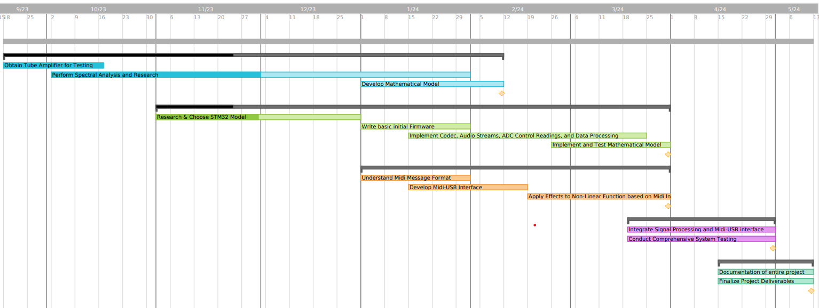

• October, 2023

1. Electrical Team
   1. Hardware Testing
      1. Testing vacuum tubes for key characteristics
         1. Harmonic & Sinusoidal Distortion
         2. Filament Temperature Distortion
         3. Clipping Characteristics
2. Software Team
   1. Microcontroller Testing
      1. MIDI/Analog audio inputs
      2. Generating Distortion through digital signal processing

November, 2023

1. Electrical Team
   1. Mathematical Model for Distortion Characteristics
      1. Based on results of Hardware Testing, build a mathematical model for how tubes distort audio signals
      2. Begin work designing Analog/Digital input/output system
2. Software Team
   1. Microcontroller Design
      1. Choosing Microcontroller components best suited for audio processing based on Microcontroller Testing results
      2. Designing User Interface for Microcontroller Distortion Control

December, 2023

1. Electrical & Software Teams
   1. Design Finalization
      1. Working with team to agree upon final design specifications & parameters
      2. Prepare rough budget for needed components for final design
      3. Conferring with client to ensure satisfaction with the final specifications
   2. Design Documentation
      1. Put together a full design for the final system
      2. Editing & Checking design documentation

Spring Semester, 2024

1. Phase 1: Sourcing & Acquiring Materials (Jan-Feb)
   1. Find sources for all needed materials and prepare final budget for submission
   2. Acquire all necessary materials project prototype
2. Phase 2: Prototyping (Feb-Mar)
   1. Begin assembling final project per project specifications
   2. Test individual systems until satisfied
   3. Assemble final product
3. Phase 3: Testing, Troubleshooting & Presenting
   1. Test the fully assembled final product, troubleshooting issues until satisfied
   2. Prepare working prototype for presentation with fully completed Documentation

## 2.5 Risks And Risk Management/Mitigation

* Technical Complexity:
  + *Risk:* The intricate nature of implementing a mathematical model for tube distortion and integrating it into a microcontroller may pose technical challenges.
  + *Mitigation:* Conduct thorough feasibility studies, prototype testing, and seek expert consultations to address potential technical hurdles.
* Resource Availability:
  + *Risk:* Delays or constraints in obtaining specialized testing equipment, electronic components, or access to required academic literature and code libraries.
  + *Mitigation:* Develop contingency plans, diversify suppliers, and maintain open communication to address and mitigate potential resource constraints promptly.
* Model Accuracy:
  + *Risk:* Deviations between the mathematical model of tube distortion and the actual distortion characteristics of vacuum tubes may affect the project's fidelity to the desired sound replication.
  + *Mitigation:* Regularly validate and refine the model through iterative testing and adjustments based on empirical results.
* Regulatory Compliance:
  + *Risk:* Failure to comply with relevant regulations and standards in audio engineering and electronic devices may result in legal or certification issues.
  + *Mitigation:* Stay informed about industry standards, engage legal experts if needed, and ensure that the project adheres to all applicable regulations.

Risk Management:

* Agile Development Approach:
  + Adopt an agile development methodology to enable flexibility and adaptability to evolving technical requirements. Regularly reassess and adjust project milestones based on progress and challenges.
* Diverse Skill Set:
  + Ensure that the project team possesses a diverse skill set covering areas such as electrical engineering, programming, and audio processing. Provide training opportunities to fill any skill gaps identified during the project.
* Continuous Testing and Validation:
  + Implement a rigorous testing and validation process at each stage of the project to identify and rectify issues promptly. This includes regular validation of the mathematical model, circuit design, and microcontroller implementation against empirical data.
* Communication and Documentation:
  + Establish clear communication channels within the team and maintain detailed documentation. Regular meetings, progress reports, and documentation reviews will enhance transparency and mitigate potential misunderstandings.
* Contingency Planning:
  + Develop contingency plans for potential delays, resource shortages, or technical setbacks. These plans should outline alternative approaches, backup suppliers, and strategies for overcoming unforeseen challenges.

## 2.6 Personnel Effort Requirements

Within the collaborative creative dynamic of the group, it is imperative that each member wholeheartedly commit the necessary time and intellectual effort to accomplish the tasks assigned to them. This commitment not only exemplifies a sense of responsibility but also serves as the linchpin for the group’s collective progress.

By emphasizing the significance of individual contributions, a collaborative environment can be better nurtured, fostering a shared commitment that underpins attainment of the Project Objectives. Recognizing and appreciating each member’s dedication to the overall project lays the foundation for a cooperative synergy, ensuring the group’s success in attaining its collective goals.

## 2.7 Other Resource Requirements

Beyond physical resources, additional requirements are predominantly tied to the necessity for comprehensive scientific analysis within the realm of Audio Engineering. This involves delving into extensive academic literature, particularly scholarly papers sourced from institutions such as the Audio Engineering Society (AES), and the Institute of Electrical and Electronics Engineering (IEEE).

In tandem with the necessary academic literature, this project relies on a diverse set of audio-centric code libraries, crucial for tasks like MIDI-USB integration and nuanced real-time audio signal manipulation. Access to these libraries vastly expedites the development process, ensuring a robust foundation for precise audio processing.

# 4 Design

## 4.1 Design Content

A mathematical model for:

a. Peaking Distortion

b. Harmonics of Incoming Signals

c. Filament Temperature Fluctuations

2. Digital Synthesis for:

a. Peaking Distortion

b. Harmonics Introduction

c. Filament Temperature Simulation

3. Integration for Analog inputs/outputs

a. Analog Amplification following DAC on output

b. Analog input/output ports

### 4.2 Design Complexity

The complexity inherent in procuring the requisite data for our mathematical model necessitates the orchestration of a sophisticated ensemble of equipment. Within this array, we meticulously integrate a low-power vacuum-tube amplifier, a Digital Multimeter, a Digital Oscilloscope, a Function Generator, a Focusrite Scarlett 2i2, and a laptop outfitted with recording software—specifically Audacity and MATLAB. This diverse suite of instrumentation stands as an indispensable toolkit, affording us the capacity to capture audio with optimal fidelity directly from the source, whether it be a computer employed in music tests or the function generator utilized for nuanced harmonic analysis.

This strategic amalgamation of advanced tools serves as the linchpin of our data acquisition process, enabling the meticulous recording of audio under a myriad of conditions. Each condition is thoughtfully designed to scrutinize the nuanced effects introduced by the vacuum-tube amplifier across various scenarios. Subsequently, harnessing the computational prowess of sophisticated programs such as MATLAB, we undertake the parsing of voluminous data extracted from the recorded audio files.

This computational journey becomes instrumental in conducting intricate analyses, unraveling key insights, and extracting parameters that form the bedrock of a highly precise and comprehensive mathematical model. This model, a testament to the confluence of cutting-edge instrumentation and analytical prowess, stands as a sophisticated representation of the functional distortion inherent in the audio signal's transformative journey—from its pristine, original state to the enriched, tube-amplified rendition. The meticulous orchestration of this equipment suite and computational finesse ensures a depth of analysis that aligns with the intricacies of the project's engineering complexity.

### 4.3 Modern Engineering Tools

Keysight InfiniiVision 4-Channel Oscilloscope - Signal/Frequency Analysis

Keysight EDU33210 SBE Function Generator - Reference Signal Generation

STM32F7 High-Performance Microcontroller - Real-time Audio Processing

LTSpice/PSpice - Vacuum Tube Component Simulation

Scarlett 2i2 Digital Audio Interface - Analog to Digital Converter with Adjustable Amplifier and Resolution

## 4.4 Design Context

Within the expansive tapestry of the music community, the Vacuum-Tube stands as a coveted and revered component, celebrated for its unparalleled ability to introduce distinctive distortion characteristics into an otherwise generic audio signal. This project, rooted in an acute awareness of the profound impact such analog elements can have on sonic aesthetics, directs its focus towards a specific demographic—the budget-conscious musician. This musician, while inherently drawn to the allure of the Vacuum-Tube's acoustic qualities, navigates the delicate balance of a finite financial spectrum, seeking to harness these sought-after tonal nuances without succumbing to the exorbitant costs associated with acquiring high-quality analog equipment.

By homing in on the musician on a budget, this project extends an inclusive invitation to a community of artists who, despite financial constraints, yearn to imbue their soundscapes with the warmth, richness, and distinctive coloring that the Vacuum-Tube uniquely imparts. This endeavor transcends the mere replication of sound; it encapsulates a mission to democratize access to the sonic aesthetics of the Vacuum-Tube, fostering a creative environment where financial limitations cease to be a hindrance to the pursuit of musical excellence. In essence, this project becomes a sonic egalitarian venture, ensuring that the transformative power of the Vacuum-Tube is not confined to the realms of luxury but becomes an accessible and integral component in the artistic journey of every budget-conscious musician.

While serving as a cost-effective gateway to the coveted vacuum-tube sound, the Super-Tube amplifier distinguishes itself by integrating MIDI-Instrumental functionality. This addition not only retains its essence as a traditional Tube-Preamp but expands its utility, offering artists unparalleled creative freedom. This versatility transforms the Super-Tube into a dynamic platform that accommodates a spectrum of creative visions. The MIDI-Instrumental functionality allows seamless integration with various MIDI-enabled instruments and software, enabling real-time manipulation of parameters, textures, and nuances. In essence, the Super-Tube transcends its budget-friendly identity, becoming a catalyst for innovation and inspiration across diverse musical genres.

| **Area** | **Description** | **Examples** |
| --- | --- | --- |
| Public health, safety, and welfare | Promotes self-manufacture of the product due to availability and cost effective materials. All dangers therein are thus possible. | An individual burns themselves while attempting to solder the PCB for the Microcontroller necessary for the device to work properly. |
| Global, cultural, and social | This project widens the creative freedom for artists wishing to expand upon the familiar Tube-Amp sound. | An artist otherwise limited by the analog simplicity of a Vacuum-Tube amplifier is able to improve upon the sound by changing the tonal characteristics as they see fit. |
| Environmental | Materials necessary for individuals to manufacture their own versions of the Project device may cause environmental problems. | Use/Misuse of 3D-printed materials may cause a greater quantity of plastic-waste to enter landfills. |
| Economic | Reduced cost-of-entry into an otherwise exclusive field of Vacuum-Tube sound for musicians. | Musicians who wish to enter the performance/recording scene where the cost barrier would be otherwise insurmountable can now afford to create the music they wish to. |

### 4.5 Prior Work/Solutions

In our exploration of products available online, we've come across numerous claims of digitally emulating the distinct sound of a vacuum tube amplifier. Notably, these offerings predominantly manifest as VSTs (Virtual Studio Technology), existing solely in the digital realm and requiring a computer for operation. Our product diverges from this digital landscape as we envision it to be a tangible, physical amplifier, providing a unique and authentic experience beyond the confines of virtual emulation. This differentiation is not only in the nature of our product but also in the user interaction it offers, distinct from the computer-centric operation of VSTs. Here are key points that underscore the differences:

* Physical Presence:
  + *Online Products:* Existing as VSTs, they lack a tangible, physical form and are confined to digital platforms.
  + *Our Product:* A physical amplifier that can be interacted with directly, offering a hands-on experience.
* Operational Independence:
  + *Online Products:* Dependence on a computer for operation, limiting flexibility and mobility.
  + *Our Product:* Operates independently, allowing users to engage with it without being tethered to a computer.
* Authentic Amplification:
  + *Online Products:* Emulate tube amplifier sounds in a digital environment.
  + *Our Product:* Physically replicates the authentic sound characteristics of a vacuum tube amplifier.
* User Interaction:
  + *Online Products:* Interface through computer screens, limiting tactile engagement.
  + *Our Product:* Facilitates direct user interaction, offering a more immersive and intuitive experience.
* Versatility:
  + *Online Products:* Primarily suited for digital audio workstations and studio setups.
  + *Our Product:* Versatile application, suitable for live performances, rehearsals, and various musical environments.

By materializing our vision as a physical amplifier, we aim to bridge the gap between digital emulation and tangible, authentic amplification, offering musicians a unique and versatile tool for their sonic endeavors.

## Design Decisions

To get the audio from an analog source onto the Microcontroller for processing, an Analog to Digital Converter (ADC) is necessary. Usually, an ADC with a resolution of between 12 and 16 bits is used in commercially available Digital Audio Systems. But, with greater resolution comes the necessity for greater processing power for the Microcontroller. So, to strike a balance between audio quality and processing power, we have elected to utilize the 12-bit ADC/DAC option for the STM32F7’s Audio input/output system.

In our design approach, we prioritize versatility by incorporating robust connectivity options into the Super-Tube amplifier. This decision encompasses standardized Analog inputs for traditional audio sources, ensuring compatibility with instruments like guitars and keyboards. Simultaneously, we embrace MIDI standardized messages for the Instrumental Array, providing users with a pathway for exploring innovative MIDI-controlled manipulations.

Along with resolution, and I/O format considerations, we also have to consider the Audio Processing itself, which we have decided to conduct on the STM32F7 Microcontroller. This Microcontroller is very easily commercially available, allowing for even inexperienced artists to easily gain access. Also, it is powerful enough to conduct all the audio processing we need plus some due to it utilizing the entire computational abilities of the Cortex-M7 core processor.

## Proposed Design

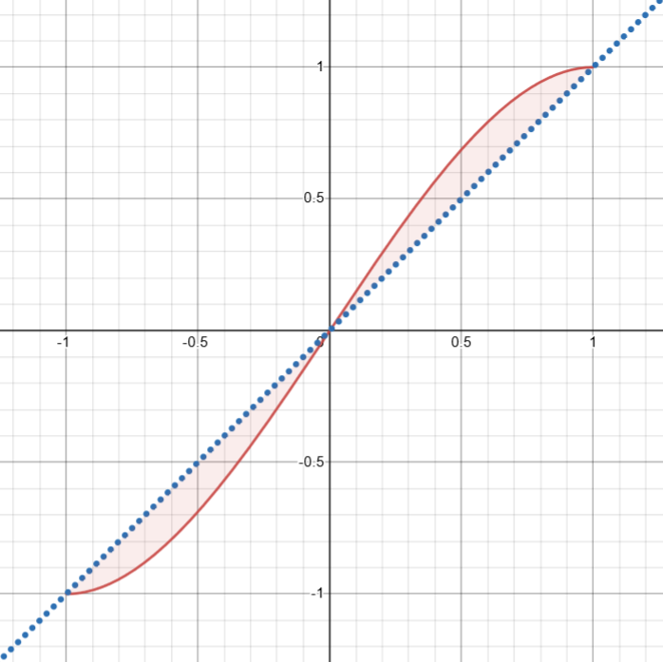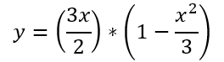

The Above Nonlinear Distortion Function has been derived using the mathematical model developed by Yamaha engineers during their attempts at Vacuum Tube emulation. Using this Nonlinear function as a jumping-off point, we are refining our mathematical model for what makes a Vacuum-Tube sound like a Vacuum-Tube through experimental development.

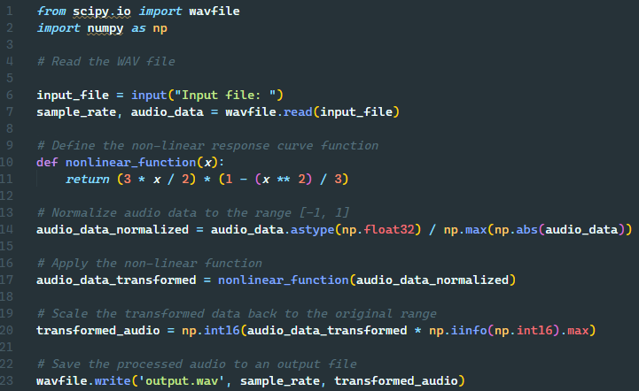

Using the following Code implementation of the above nonlinear function, we have been able to create an exceptionally rudimentary version of the overall distortion we wish for the final product.

### 4.7.1 Design 0 (Initial Design)

### Design Visual and Description

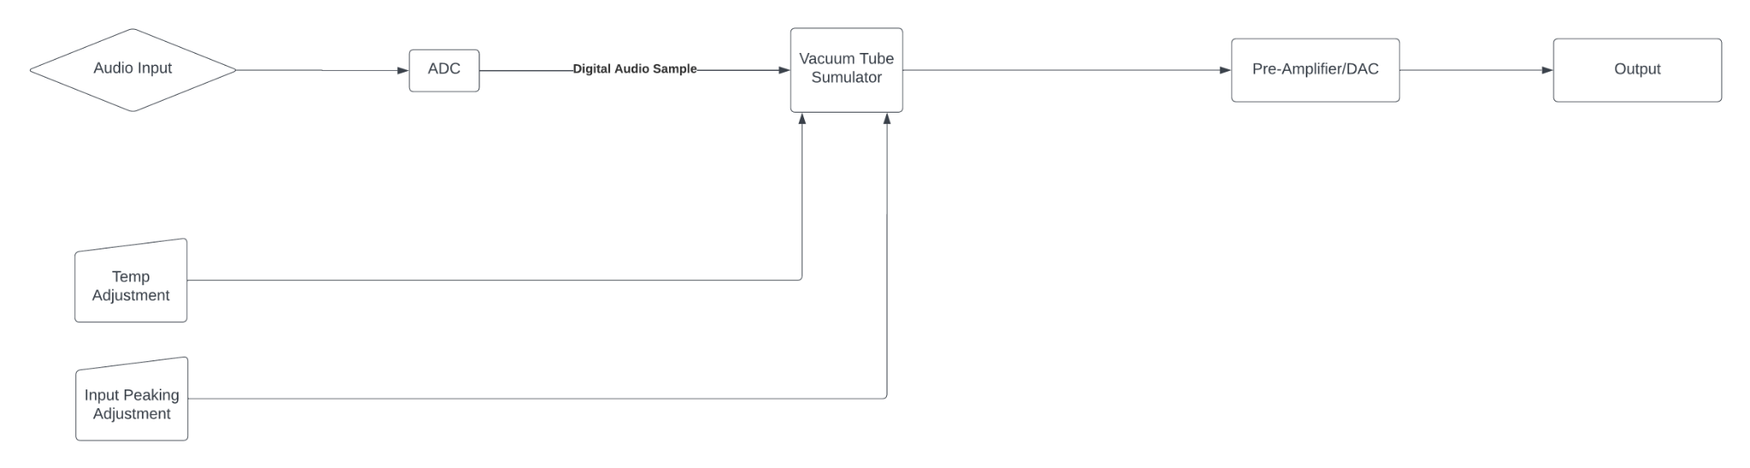

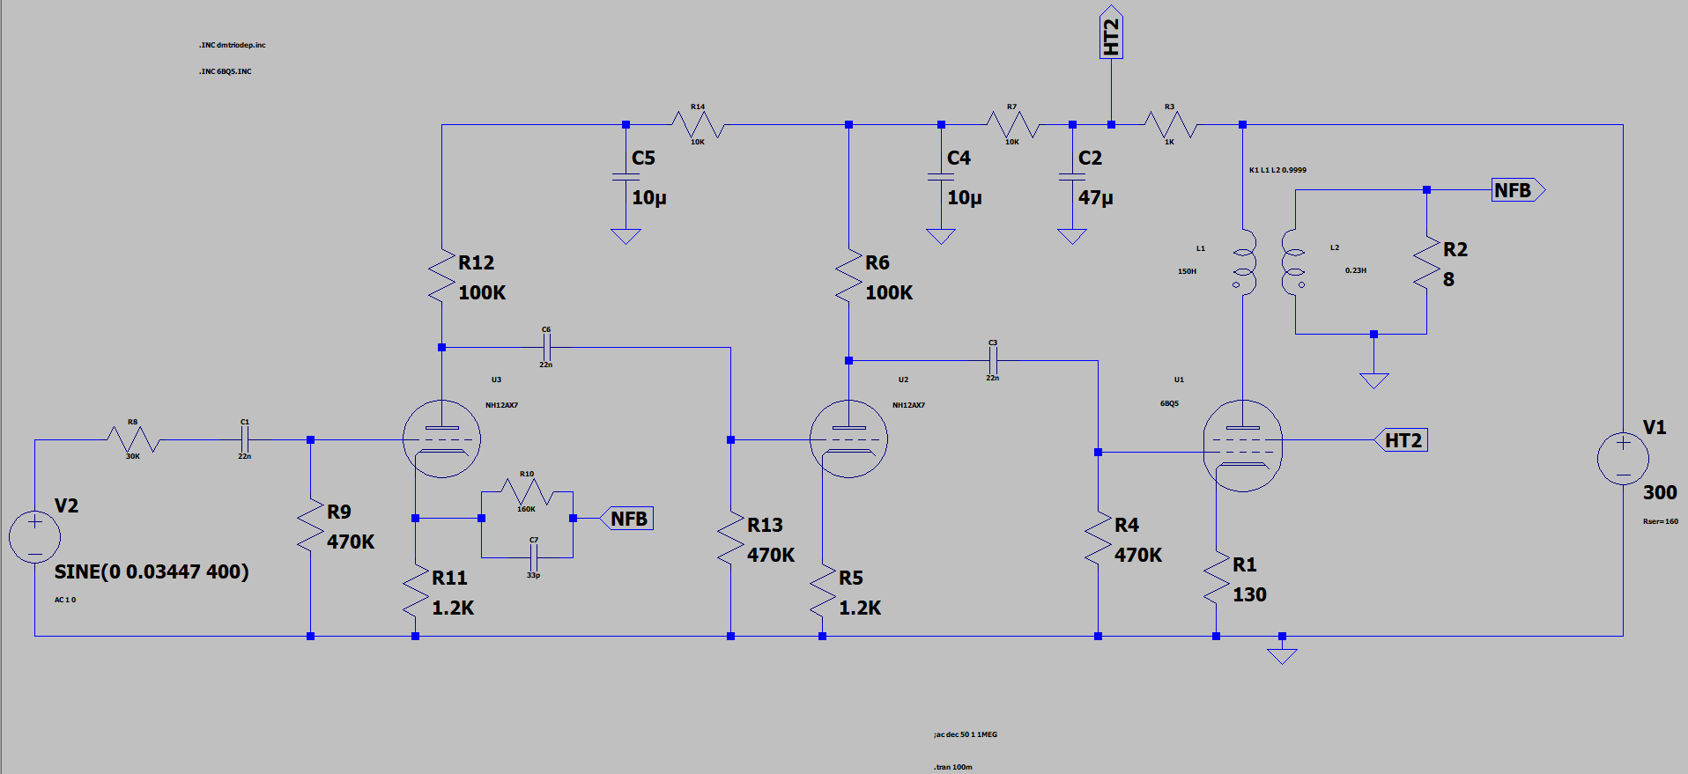

Our initial design relied on running a PSpice model of a Vacuum-Tube Audio Amplifier following design for a 5 Watt Vacuum-Tube based Pre-Amplification system utilizing 12AX7 Triodes for the both filtering stages and a 6BQ5 Power-Pentode for the final Amplification Stage.

In terms of User Inputs, we decided to include user control over the temperature of the Filament temperatures within the simulated circuit shown above, along with an Input Peaking control that would change the input amplitude to either enter or avoid the saturation region of the Simulated Triodes. (This input area would take the place of the Sinusoidal Voltage Generator to the far left of the above diagram).

Once the Audio Sample passes through the Simulated Circuit, it would then pass into the Digital to Analog Converter, then to the output.

### Functionality

This design was created to as closely as possible emulate the specific qualities of the Vacuum-Tube Preamplifier it was based off of, which is the Fender ‘57 Custom Champ 5 Watt Vacuum-Tube Amplifier.

This being the designed functionality, the user would be able to introduce the Vacuum-Distortion the same way that they might utilize any other Effects-Based Direct Input (DI) unit, wherein the user would plug in the audio source into the ¼” TRS (Tip-Ring-Sleve) port on the front of the device, and run a cable between the ¼” TRS Output of the device and the secondary amplification/recording device they plan to use.

During use, the user would be able to use the knobs on the exterior of the device to effect systems such as the simulated Tube Filament Temperature or the Input Peaking to introduce distortion to their liking.

### 4.7.2 Design 1 (Design Iteration)

Between Design Iteration 0 and Design Iteration 1, the central concept for how the effect of Vacuum-Tube emulation would be achieved. Following some extensive research, it was discerned that simulating the circuit as we originally intended would be wildly computationally expensive, as an individual simulation would need to be run for each individual audio sample in real time. This would be totally unachievable given the naturally limited computational resources of a Microcontroller platform.

Along with computational problems, there also arose the issue of accuracy, as during out limited testing with the format of using a Circuit Simulation to introduce the desired distortion effects, it was seen that even a minute change in any of the parameters caused the output to vary wildly and the audio quality to degrade extensively.

To resolve this computational intensity problem along with the acoustic dissonance problem we decided to adopt a more robust and altogether computationally prudent method of mathematical modeling for our next design iteration.

Also in this iteration comes the idea of the MIDI Instrument. In simulating the distortion using a mathematical model instead of a Circuit Simulation, it is very simple to run a MIDI Message into the system and have it run an oscillation of the final audio signal given overwhelming creative freedom to the artist using the device.

### Design Visual and Description

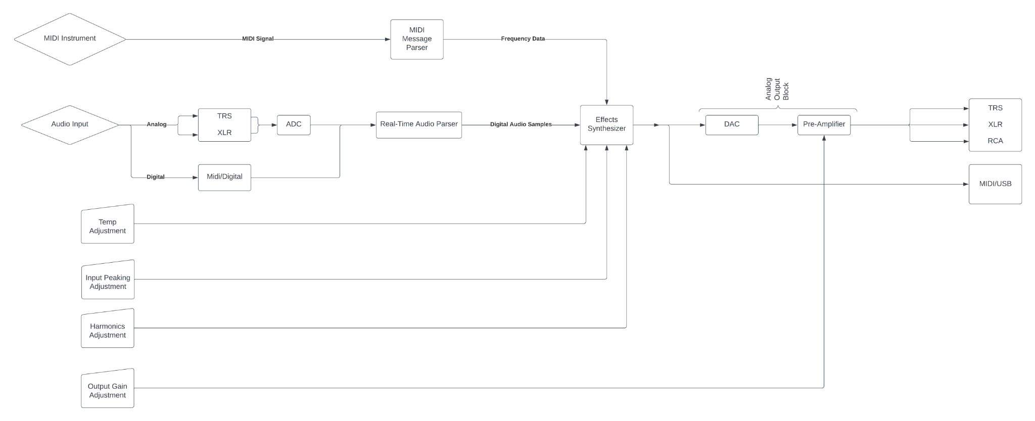

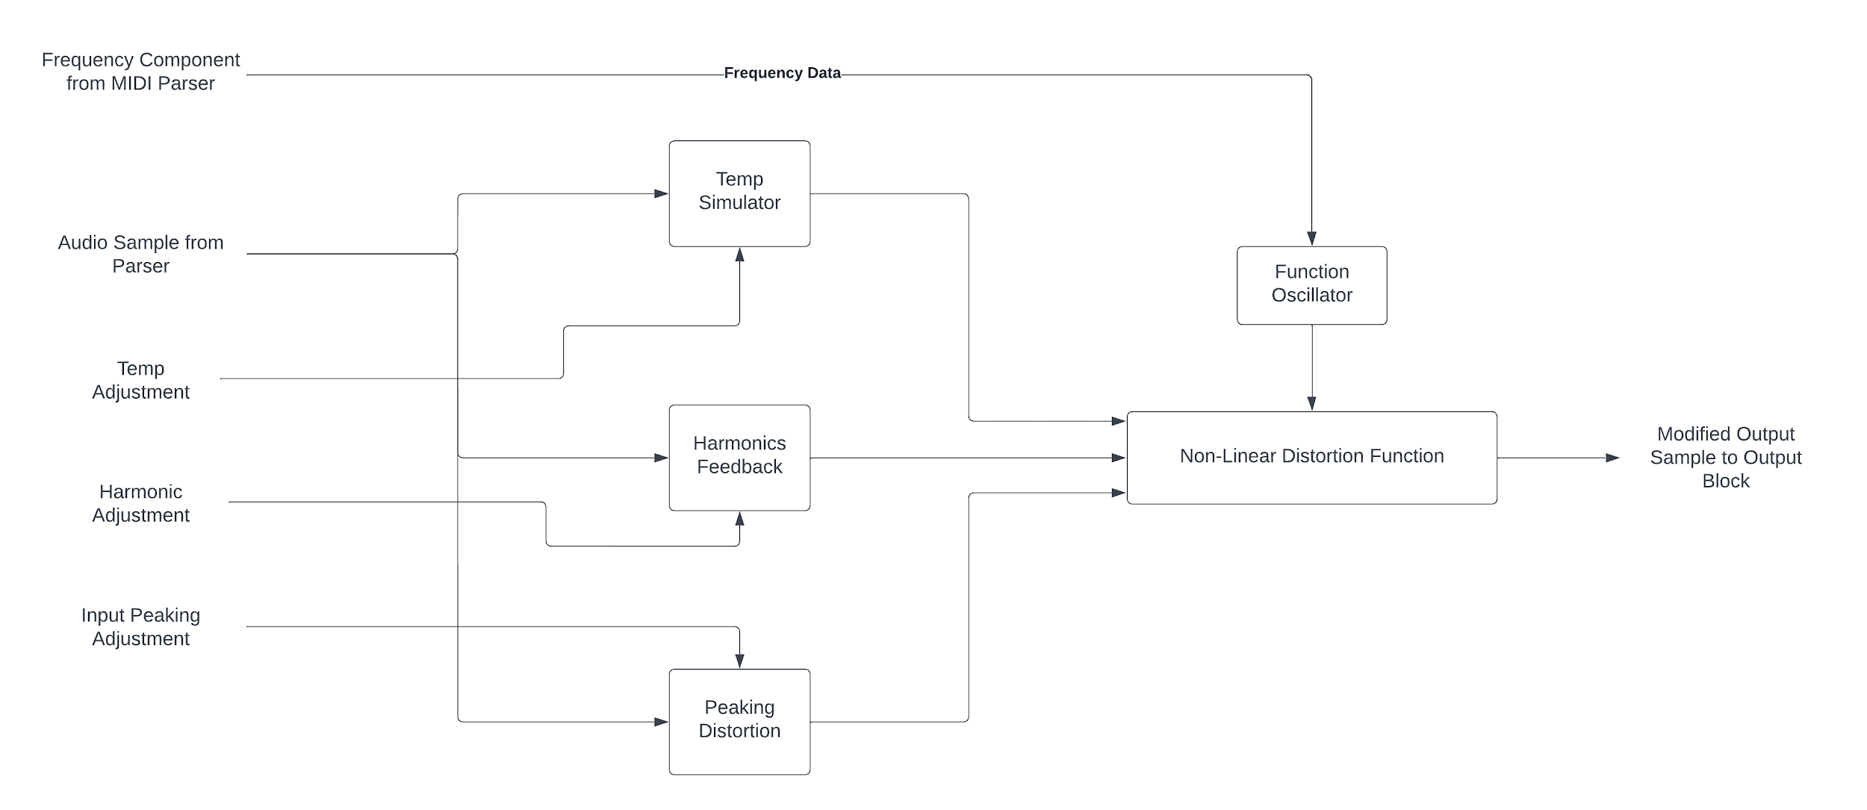

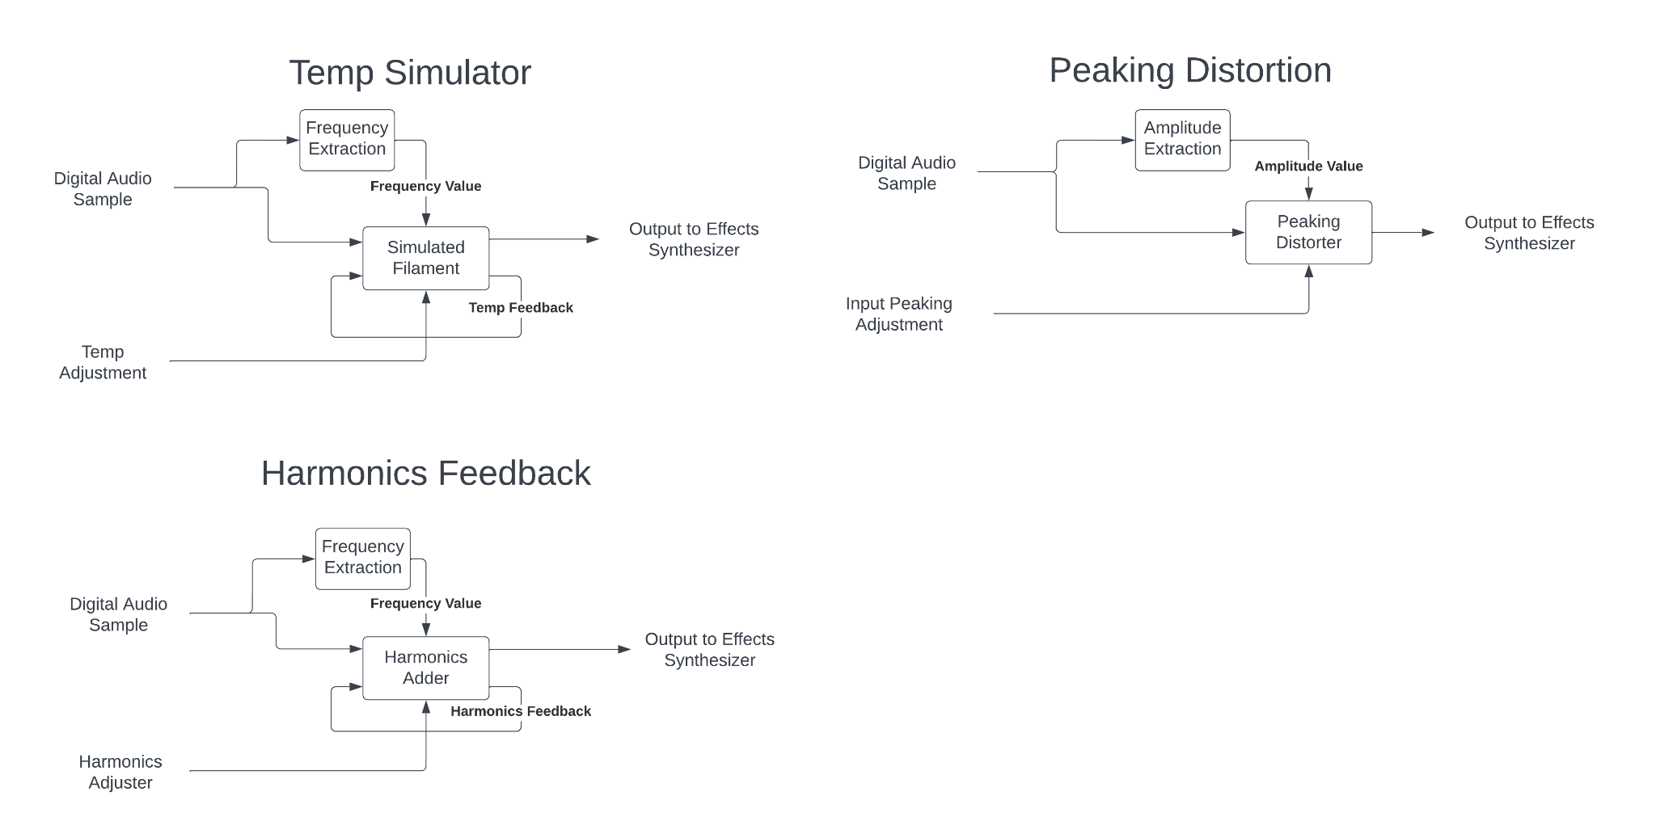.

In the above three flowcharts, the method for approximating the distortion of a Vacuum-Tube amplifier using a programmed mathematical model is shown. When the audio signal enters the system, it is first processed from its original format into a unified AES3 digital audio signal, whose samples can then be parsed out before being sent to the Effects Synthesizer for processing.

Along with the two inputs from the previous iteration of the design, the Temp Adjustment and the Input Peaking Adjustment, two more user adjustable settings are available. The Harmonics Adjustment, which adjusts the severity of the harmonics added in by the non-linear function, along with the Output Gain Adjustment, which simply adjusts the gain of the final analog amplifier at the end of the circuit.

Once within the Effects Synthesizer, the audio sample is run in parallel through the three separate effects, where the distortion is added to each before the signal is recombined in the final audio processor. It is also within the effects synthesizer that the MIDI signal is added to modulate the Nonlinear Function at the heart of the mathematical model.

This design iteration has made many major improvements over the initial design beyond simply being computationally cheaper. It also massively increases the sensitivity with which the distortion effect can be manipulated by the user and thus extends creative freedom without adding unneeded control complexity.

## 4.8 Technology Considerations

**STM32 Microcontroller Platform:**

Achieving real-time processing is critical for musical applications. Balancing the complexity of signal processing algorithms with the need for low-latency performance is a key trade-off. The processing capabilities of microcontrollers, including STM32, are limited compared to more powerful processors. This may impose constraints on the complexity of signal processing algorithms that can be implemented. While a STM32 is powerful, optimizing code for memory and processing efficiency is crucial to make the most of the limited resources.

**MIDI-USB Interface:**

MIDI-USB technology offers a standardized and widely accepted communication protocol for musical instruments. It provides a convenient way to connect and communicate with various MIDI-enabled devices.

USB interfaces might introduce latency, and careful consideration is required to minimize this latency for real-time audio processing..

**Tube Amplifier for Testing:**

Tube amplifiers can provide a unique and desirable audio character that many musicians appreciate. The inclusion of a tube amplifier in testing allows for a more realistic mathematical model and evaluation of the system's performance.

## 4.9 Design Analysis

–  Did your proposed design from 4.7 work? Why or why not?

–  What are your observations, thoughts, and ideas to modify or iterate further over the design?

# 5 Testing

Testing is an **extremely** important component of most projects, whether it involves a circuit, a process, power system, or software.

The testing plan should connect the requirements and the design to the adopting test strategy and instruments. In this overarching introduction, given an overview of the testing strategy. Emphasize any unique challenges to testing for your system/design.

## Unit Testing

Audio Inputs/Outputs

All inputs & outputs can be tested by first running an audio signal through a known I/O system, then compare the audible results to that of the project I/O without the distortion factor

Non-Linear Effects Synthesis

The same non-linear distortion factors can be emulated using a computer program.

Then, a known signal can be passed through both the computer emulation and the project hardware of each individual effect, (assuming input and output have already been confirmed functional) and the results can be compared spectrally and audibly. We are using python to emulate it.

## Interface Testing

There are two interfaces within the design that demand testing; the USB interface which facilitates MIDI communication and the interactions among STM32 components. For the USB-MIDI interface, testing involves evaluating compliance with MIDI standards and ensuring the accuracy of data exchange. Furthermore, interactions among STM32 components are crucial for real-time signal processing. Simulation tools must be employed to test the composition of these interfaces. This involves validating the mathematical model and the STM32's signal processing capabilities.

Testing interfaces of various components within the project system can be difficult, but tapping the output at various places along the chain often provides useful insight.

By using output ports that would not otherwise be used, we can pull various outputs even during a single test run to see how the signal changes with each step toward the output

With this data, the source of the problem can very quickly be found by seeing where in the chain the signal deteriorates.

## Integration Testing

In our design, the most important thing to integrate will be the signal processing with the USB-MIDI capabilities.

Chain of Dependent Tasks:

Input (Analog) -> ADC -> Sample Parser -> Effects Synthesis -> DAC -> Output (Analog)

The above path shows the longest chain of dependent tasks that must be completed to fit the project requirements.

Testing the Chain of Dependent Tasks shown above can be completed by moving backwards along the chain (from the output) to find points of failure.

## System Testing

Auxiliary Task Chains:

Exterior Dist. Controls -> Effects Synthesizer -> DAC -> Output(Analog)

Effects Synthesizer -> Output(Digital)

Input (Digital) -> Sample Parser

Each different integration should follow the same testing protocol

Start at the end of the chain (tap off of last unknown element)

Work backwards towards the input

## Regression Testing

Ensuring Unit Functionality

Run a wide variety of known audio signals through both the final project hardware, along with the digital emulation of the same effects. Compare outputs both audibly and spectrally.

Run similar signals through the digital emulation, Project hardware, and the physical Vacuum Tube hardware it was designed around. Compare outputs both audibly and spectrally.

Ensure Interface Functionality

Run similar tests to the Unit level testing, but tap outputs at various points along the Chain of Dependent Tasks. Compare all tapped outputs both audibly and spectrally

Compare all results to the expected results in terms of harmonics and signal attenuation

## Acceptance Testing

New Feature Addition

System integrity will be maintained through the use of modular system construction.

The only form of interaction between each of the individual modules will be the immediate input and output.

As long as the output format of one module is compatible with the input format of the next module down the chain, no harm should be done to critical components.

All new features will be added on with this modularity firmly in mind

## Security Testing (if applicable)

## Results

Human Level Acceptance

As this project mostly deals with music, the outcome of this testing is very much subjective to the current user.

To ensure Standards Acceptance, the unit will be tested on a variety of individuals not involved in the project.

Each individual will answer a questionnaire developed by the team in conjunction with the client to ensure proper acceptance.

Final project acceptance will be at the total discretion of the Sponsoring Client.

# 6 Implementation

January, 2024

1. Acquiring Materials
   1. STM32F7 Microcontroller
   2. STM32 Compatible DAC/ADC
   3. Input/Output Hardware
2. Complete Mathematical Model
3. Assembly of Microcontroller Components

February, 2024

1. Implement Mathematical Model on Microcontroller
2. Assembly of Input/Output Hardware
3. Start Compliance Testing
4. Start Instrument MIDI Interface Implementation

March, 2024

1. Test Instrument MIDI Interface
2. First System-Level Tests
3. Continue Compliance Testing
4. Create Protocol for Acceptance Testing

April, 2024

1. Acceptance Testing Survey
2. Final System-Level Testing
3. Final Compliance Testing
4. Documentation

May, 2024

1. Finalize Acceptance Testing
2. Polish Documentation
3. Prepare Presentation

# 7 Professionalism

This discussion is with respect to the paper titled “Contextualizing Professionalism in Capstone Projects Using the IDEALS Professional Responsibility Assessment”, *International Journal of Engineering Education* Vol. 28, No. 2, pp. 416–424, 2012

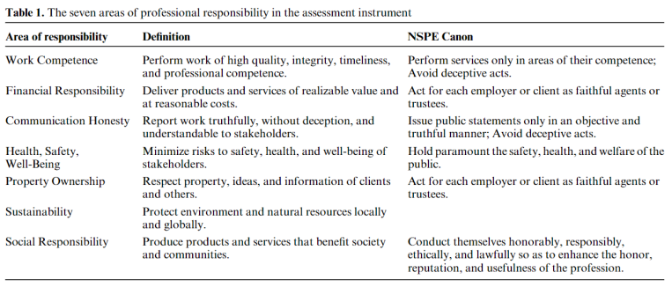

## Areas of Responsibility

The following is based on the IEEE code of ethics, available at the following link: <https://www.ieee.org/about/corporate/governance/p7-8.html>

| Area of Responsibility | IEEE-Specific Code of Ethics | Reasoning |
| --- | --- | --- |
| Work Competence | 1.6: to maintain and improve our technical competence and to undertake technological tasks for others only if qualified by training or experience, or after full disclosure of pertinent limitations; | This section of the IEEE code of ethics describes ways in which to make sure that engineers only take on work in terms of their competence. It is fairly consistent with its counterpart in the NSPE Canon. |
| Financial Responsibility | 1.4: to avoid unlawful conduct in professional activities, and to reject bribery in all its forms; | This section of the IEEE code of ethics differs from that of the NSPE Canon in its realization - financial responsibility, in the canon of the IEEE code of ethics, is closer to that of social responsibility. |
| Communication Honesty | 1.5: to seek, accept, and offer honest criticism of technical work, to acknowledge and correct errors, to be honest and realistic in stating claims or estimates based on available data, and to credit properly the contributions of others; | This section of the IEEE code of ethics is very similar to that of the NSPE canon in its latter half, but does expand upon communication with coworkers as well. It establishes the ways in which an engineer should strive to communicate with their coworkers |
| Health, Safety, Well-Being | 1.1: to hold paramount the safety, health, and welfare of the public, to strive to comply with ethical design and sustainable development practices, to protect the privacy of others, and to disclose promptly factors that might endanger the public or the environment; | This section of the IEEE code of ethics describes ways in which the engineer should strive to support both the public and their fellow man, and is consistent with that of the NSPE Canon. |
| Property Ownership | 1.5: to seek, accept, and offer honest criticism of technical work, to acknowledge and correct errors, to be honest and realistic in stating claims or estimates based on available data, and to credit properly the contributions of others; | This section of the IEEE code of ethics is fairly consistent with that of the NSPE Canon in its final line, and additionally describes ways in which the engineer should strive to make claims as well as criticism, compounding it with that of Communication Honesty. |
| Sustainability | 1.1: to hold paramount the safety, health, and welfare of the public, to strive to comply with ethical design and sustainable development practices, to protect the privacy of others, and to disclose promptly factors that might endanger the public or the environment; | This section of the IEEE code of ethics is not present in the NSPE canon, and thus cannot be compared. It describes in great detail the efforts an engineer should take in regards to how they approach the matter of public welfare. |
| Social Responsibility | 1.10: to support colleagues and co-workers in following this code of ethics, to strive to ensure the code is upheld, and to not retaliate against individuals reporting a violation. | This section of the IEEE code of ethics is fairly consistent with that of the NSPE Canon, with no major deviations. It implores all engineers to best service the larger community with as much support as they can muster. |

## 7.2 Project Specific Professional Responsibility Areas

| Area of Responsibility | Team Performance | Reasoning |
| --- | --- | --- |
| Work Competence | High | As this is a multidisciplinary project, we made sure to best divide the work up by available members and resources based on what they were most comfortable - and confident in - tackling. |
| Financial Responsibility | High | This project is fairly low cost, but we have taken great efforts to make sure that all financial matters related to this project are well documented and approved by all applicable parties. |
| Communication Honesty | High | We do our best to meet three times a week - twice as a team, the third with our faculty advisor to make sure that, at all times, our mentors and colleagues are aware of the current status of the project. |
| Health, Safety, Well-Being | High | We take appropriate safety precautions to make sure that there is no risk of injury at any point within this project, from grounding straps to training on how to use oscilloscopes and other electronic equipment for non-EE majors. |
| Property Ownership | High | As this project builds on those that came before, we are fastidious with the documentation of sources that we use throughout its creation. |
| Sustainability | Low | This project could not be described as ‘good for the environment’ or developed with sustainability in mind. |
| Social Responsibility | High | Our product benefits the community that would see the most use from it - audiophiles! We also make sure to interview potential users for product and market fit to make sure it best appeals to them. Additionally, we conduct ourselves as ethically as we can, and pride ourselves on our open and honest communication. |

## 

## 7.3 Most Applicable Professional Responsibility Area

The most applicable area of responsibility to our team is that of work competence. As this is a multidisciplinary project, we made sure to best divide the work up by available members and resources based on what they were most comfortable - and confident in - tackling. At all times, we communicate with our team members about what needs to be done and divide responsibilities up depending on applicable skill sets through honest and open communication. We would thus agree that the professional responsibility area most applicable to our project is that of work competence.

# 8 Closing Material

## 8.1 Discussion

Discuss the main results of your project – for a product, discuss if the requirements are met, for experiments oriented project – what are the results of the experiment, if you were validating a hypothesis – did it work?

In this project, we have successfully been able to create a program that can emulate a tube amp, and play any high order function we put into it over the input. Going forward we still have to create the product, but so far we have been able to successfully create the framework for our final project to work, and next semester all we have to do is follow our plan out and we will have a successful final product. With our current progress we are able to meet the initial guidelines of emulating a tube amp, but we are only missing the requirements of processing it in real time, and having a physical product.

## 8.2 Conclusion

Summarize the work you have done so far. Briefly re-iterate your goals. Then, re-iterate the best plan of action (or solution) to achieving your goals. What constrained you from achieving these goals (if something did)? What could be done differently in a future design/implementation iteration to achieve these goals?

This semester we have spent a lot of time researching approaches to complete this project, running tests on a tube amp to see how one behaved live, creating a program to run any audio input through a high order function and choosing a microcontroller that could successfully implement this best, and also creating a design plan to end up with a finished product at the end of next semester.

## 8.3 References

## 8.4 Appendices

### Research on Methods of Tube Amp Emulation & Commercially Available

**What you have to emulate in a tube amp.**

* Triode
  + Anode -> Grid -> Cathode
    - In a triode the amplification is obtained by inducing and controlling an electric field between the anode and the cathode
      * You control this by changing grid bias, giving the grid more positive bias leaves to more plate bias (anode side)
      * Eventually the grid does saturate if too high, and if too low no current goes from cathode to anode.
      * Now that you can control the current on the anode side, you hook up a power transformer the other side and effectively have an amplifier that doesn’t really change the output signal.
      * The cathode is heated to lower the threshold for the cathode to emit electrons. Electrons are prone to stream from the negative cathode to the positive anode. The electric stream from the cathode to the anode in the triode induces a current. By controlling the electric field the current through the triode is indirectly controlled. The control mechanism is achieved by applying a negative voltage at the gird between the anode and the cathode.
* Pentode
  + Anode -> Control Grid -> Screen Grid -> Suppressor Grid -> Cathode
    - Control grid: functions like the grid in the triode.
    - Screen grid: focus the electron beam so that more of the jumping electrons make it to the anode.
    - Suppressor grid: hinders electrons to jump back to the screen grid
* Benefits of each
  + Triode
    - Due to the randomized division of the cathode flow across the screening array and the anode, pentodes exhibit increased distortion (partitioning sound).
    - Pentode
    - Fluctuations in Supply Voltage do not matter as much compared to a triode
    - Because of the screening action of the additional grid, pentodes (and tetrodes) have substantially less feedback impedance.
* **General Approaches to all Methods**
  + White Box
    - This approach derives the full third-order transfer function with no approximations for the filter by symbolic circuit analysis. Because the coefficients are described as algebraic functions of the parameters, this method is fully parametric.
    - This method doesn’t produce 100% accurate results as generally assumes everything works perfectly and not always rooted in reality.
  + Grey Box
    - Uses Math to try and emulate a tube amp 100%, and then uses real data afterwards to try and edit the output to line up to reality
    - In general uses white box method and black box method right after
  + Black Box
    - In summary, black-box approaches decide on a particular filter structure, and then they decide on coefficients for that structure to match the response of the target system. Ad hoc mappings from parameter space to coefficient space parameterize the filter
    - You look at the input and output of a signal and try to emulate the input to output through approximations such as a look-up table or waveshaping.

**Non linear Methods for Emulating a Tube Amp**

1. Waveshaping
   1. This is the easiest way to emulate a tube amp and the theory is to apply an instantaneous nonlinear mapping from the input variable to the output variable.
      1. Early formula developed by Yamaha (19790) is



* + - 1. In this formula the input has to be bounded between 1 & -1
    1. Doidicet formula



1. Look-up Table
   1. Kramer (1991)
   2. In this method, the system reads the input-output relation from a pre-stored table
2. Oversampling (TubeTone Modeling)
   1. Line 6 Company (Late 1990’s)
   2. Nonlinear signal processing blocks are known to expand the bandwidth of the incoming signal, which in a DSP system can cause aliasing if the bandwidth of the output exceeds the Nyquist frequency (i.e., half the sampling rate). An amplifier model can distort harmonic signals such as a guitar tone and produce many new harmonics in the output that, through aliasing into the audio range, are no longer harmonically related to the original tone. (A Review of Digital Techniques for Modeling Vacuum-Tube Guitar Amplifiers)
   3. In general if you oversamplify a signal and then amplify that signal in a digital signal processor, before sampling it at the Nyquist frequency again, you will have some more new harmonics that you didn’t have before.
3. Customized Waveshaping
   1. Fernández-Cid and Quirós (2001)
   2. An extension of waveshaping, you use a filterbank to separate your input signal into a bunch of different frequency signals, you than apply a unique nonlinear mapping to each of you different frequency signals.
4. Gustafasson (2004)
   1. In general, the theory is that a circuit looks at a signal for the last few milliseconds and depending on if the input signal is decreasing or increasing, he will then use a lookup table to decide the output. This method can also be used with customized waveshaping where know the output depends on the frequency, and its recent history.

**Commercially Available Tube Amp Emulators**

**TUBE AMP EMULATORS- VINTAGE TUBE AMP SOUND WITHOUT ALL THE HARDWARE**

IDESIGNSOUND

<https://www.idesignsound.com/tube-amp-emulators/>

These are all software, listed summarized top 3 with features

1. Bias FX2
   1. Features
      1. 100 different amplifiers that it can emulate
      2. 122 effects for the amplifiers
      3. 210 common presets for common amplification and distortions
      4. 20 guitar tone models
      5. Improved midi functionality
      6. new fuzzes and time modellers, harmonizers, and complementary Bias pedal programs
   2. This emulator works on a subscription model
2. Ignite Amps Emissary
   1. Features
      1. Can model real tube amps along with their parts rather than just give an output based on input
      2. Models real triodes and pentodes with IA’s 3rd-gen triode-modeling engine
         1. dynamic EL34, 6L6GC and KT88 pentodes and tetrodes analog modelling modes
      3. two selectable channels
      4. selectable oversampling
      5. plethora of selectable modes, effects, timbres, and tones.
      6. The software offers a highly authentic UI, which basically represents an actual tube amp, along with input loops, tone control knobs, split channels, and such.
   2. This Tube amp emulator is specifically meant for guitars, and is relatively cheap among the tube amp software commercially available
3. Kaussa Matchlock
   1. Features
      1. It offers classic, iconic sounds sampled from Fender one of the biggest guitar brands
      2. Can simulate their different characteristics of popular models
         1. Fender’s Twin Reverb
         2. Super Reverb
         3. Custom Vibrolux Reverb
      3. ttwo channels (boost & clean)
      4. five cabinets
      5. high and low-pass filters
      6. 7 different types of microphones from Shure, Sennheiser, Neumann and AKG
      7. fully adjustable microphone positions and placements
      8. built-in noise gates

**Hardware Tube Amp Emulators**

*note these were harder to find and didn’t seem to be that many

*The vast majority where amps that boasted distortion capabilities allowing you to also simulate a tube amp

*Only one specifically designed to simulate a tube amp was the Tech 21

1. Tech 21 SansAmp Classic Tube Amp Emulator Pedal
   1. Eight character switches which adjust the fine and subtle nuances of tonality, harmonics, and dynamics
   2. Input Switch: A three-position Input switch gives you a choice of pre-amp styles: Lead (Marshall-style), Normal (Mesa Boogie-style), and Bass (Fender-style)
   3. Flexible and User-Friendly: SansAmp Classic was specifically engineered with a flat output to provide maximum flexibility and control with external EQ. It is a flexible, user-friendly, robust device that delivers the warm, rich, natural tones of the most desirable tube amplifiers on the planet
   4. Knobs Controls: The SansAmp Classic’s knob controls shape pre-amp contours, power amp contours, volume, and final tone
2. JOYO American Sound Amp simulator Pedal
   1. subtle overdrive simulating fender-style tube amps near full volume
   2. When used as a clean boost you get more liquid / sonic gold. Compression and fatness that you usually don't hear from a pedal.
   3. Quality pots, jacks and components ensure that the sound it equally as impressive when you get going.
   4. 40$ and simulates and can simulate expensive tube amps very well
3. Universal Audio OX Reactive Amp Attenuator with Speaker Modeling
   1. With the Universal Audio OX Amp Top Box, you can play your favorite tube amplifier at its sonic sweet spot at any volume level
   2. UA's Dynamic Speaker modeling technology, you'll be able to access dozens of spot-on mic and guitar cabinet emulations.
   3. Premium analog components and one of the world's best reactive load circuits ensure you'll hear all the dynamics and harmonic complexity your amplifier has to offer.
   4. The OX Amp Top Box is a powerful solution for recording, allowing you to achieve those cranked-amp tube tones at any volume level.
   5. Many recording guitarists at Sweetwater prefer this recording method for maximum sonic control. Instead of a speaker cabinet, plug your tube amp into the Universal Audio OX Amp Top Box to explore a whole new range of tonal possibilities.

### 8.4.1 Team Contract

Team Members:

1) Jack Cassidy 2) Ian Bixler

3) Harry Burnick 4) Ben Mullin

5) Julia Kroeper 6) Bradley McClellan

**Team Procedures**

1. *Day, time, and location (face-to-face or virtual) for regular team meetings:* Meetings weekly, on Mondays at 11 am. In the Transformation Learning Area.
2. *Preferred method of communication updates, reminders, issues, and scheduling (e.g., e-mail, phone, app, face-to-face):* Face to Face meetings preferred for design, and Discord for any other communications.
3. *Decision-making policy (e.g., consensus, majority vote):* Majority vote
4. *Procedures for record keeping (i.e., who will keep meeting minutes, how will minutes be shared/archived):* One person is assigned to take basic notes on meeting procedure and decisions made.

**Participation Expectations**

1. *Expected individual attendance, punctuality, and participation at all team meetings:* Punctuality to all meetings is expected, but excused absences will be permitted if circumstances require.
2. *Expected level of responsibility for fulfilling team assignments, timelines, and deadlines:* High expectations for fulfilling assignments, with strict adherence to deadlines.
3. *Expected level of communication with other team members:* Teammates are expected to communicate to one another readily.
4. *Expected level of commitment to team decisions and tasks:* High level of commitment to the project group, with all teammates participating in the decision making process and all assigned tasks.

**Leadership**

1. *Leadership roles for each team member (e.g., team organization, client interaction, individual component design, testing, etc.):* - Git Manager, Team Lead, Secretary, Client Interaction, Treasurer
2. *Strategies for supporting and guiding the work of all team members:* Consistent communications between teammates, along with organization of members and materials as they relate to each task.
3. *Strategies for recognizing the contributions of all team members:* Detailed documentation of each task along with notes on team member’s responsibilities.

**Collaboration and Inclusion**

1. *Describe the skills, expertise, and unique perspectives each team member brings to the team.*

Write a sentence or two about yourself and what you bring to the team.

**Benjamin Mullin:** I am a CYB E major with a minor in Music Technology. I have experience with logic circuit design, although my strong suit is more on the programming side of things. As part of my minor, I’ve done some work with audio processing and controlling instruments with MIDI.

**Bradley McClellan:** I am a SE major who has taken many CprE courses. I have experience with many low level languages, FPGA programming, Harnessing, etc. I work as an Audio Engineer for the Music Department here at Iowa State, and I love working with Synths and related audio equipment.

**Theodore Burnick:** In Electrical Engineering, I have completed much work with filters and signal processing both as a part of my education, but also in my work as Chief Engineer of Iowa State’s Radio Station, KURE. This job has given me much experience in both Broadcast Engineering and Audio Processing/Mixing that should prove useful during this project. My job also gives me access to many musicians and artist that may be willing to act as testers later on in the development process.

**Julia Kroeper:** As an EE, I’ve worked in the past extensively on FPGA circuits and Altium layout, but from a personal perspective, I work full-time as a creative director for various convention and virtual reality spaces and as such am confident in my ability to ideate and execute on a variety of projects.

**Ian Bixler:** I am en Electrical Engineer and know more about the power side of the the degree. While this doesn’t mix great with this project, I have taken Signals and Systems 1 and 2, which should be able to help a lot when it comes to creating a new audio sound effect.

**Jack Cassidy:** As a CprE, I’ve worked a lot with both hardware and software so I can bridge the gap between both of them to make it easier. I have a lot of experience with microcontrollers and building a lot of testing applications with them. I also have a lot of experience with Git and Gitlab so I use the skills that I had from that and we are doing the development of stuff correctly.

1. *Strategies for encouraging and support contributions and ideas from all team members:*

Our team will encourage and support contributions by praising accomplishments and offering the weekly meeting space as a discussion floor where we’re able to determine the progress of each aspect of the project and identify potential improvements in each area.

1. *Procedures for identifying and resolving collaboration or inclusion issues (e.g., how will a team member inform the team that the team environment is obstructing their opportunity or ability to contribute?)*
2. Establish that a problem exists and bring it to the attention of the team lead
3. Discuss the problem and ideate on potential solutions with the team lead
4. Team lead will set the problem as something open to discussion in the next weekly meeting
5. Work with team members to find a solution that works best for all members as agreed to by a majority vote

**Goal-Setting, Planning, and Execution**

1. *Team goals for this semester:*

Meet with the client to accurately set expectations, figure out the scope of the project, come up with initial design details as well as budget, and concisely distribute an adequate amount of work per member as well as a fitting role in preparation for building and testing the project next semester.

1. *Strategies for planning and assigning individual and team work:*

Assign each member achievable tasks within or within range of their skillset - as tasks may be collaborative, assign multiple members depending on the scope of work required.

1. *Strategies for keeping on task:*

Weekly meetings will keep the team accountable, as each member will be expected to report on their progress towards each task assigned to them as well as discuss whether or not they need more help to accomplish a specific task.

**Consequences for Not Adhering to Team Contract**

1. *How will you handle infractions of any of the obligations of this team contract?*

We will discuss infractions as a team and attempt to resolve the issue with the offending member as a collective.

1. *What will your team do if the infractions continue?*

Our team will talk to the TA or project lead in order to determine what the best course of action will be moving forward.

***************************************************************************

a) *I participated in formulating the standards, roles, and procedures as stated in this contract.*

b) *I understand that I am obligated to abide by these terms and conditions.*

c) *I understand that if I do not abide by these terms and conditions, I will suffer the*

*consequences as stated in this contract.*

1) Bradley McClellan DATE 9/7/2023

2) Theodore Burnick DATE 9/7/2023

3) Julia Kroeper DATE 9/7/2023

4) Benjamin Mullin DATE 9/10/2023

5) Ian Bixler DATE 9/10/2023

6) Jack Cassidy DATE 9/7/2023